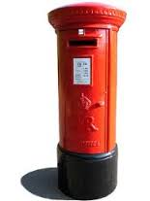
Letter to the Author

Write a letter to the author of the book or story or poem that you have just read.
You will need to lay out this in formal style (address, date, greeting, signoff).
Firstly, let them know what you think of their book.
- Your favourite character?
- Your favourite scene?
- Anything you found unexpected?
- Have you read anything else by them? What are you going to read next?

Secondly, you can ask them questions! Many authors make an effort to reply to fan-mail, so this is a great opportunity to ask them anything and everything about the book you have just read, themselves, their writing, your writing…
Some suggestions of what you might want to ask:
- When and why did they start writing?
- Where do you get most of your ideas?
- What is your favourite thing you've written?
- How do you create your characters?
- How do you beat your writer’s block?
- What tips would you give me to be a better writer?

…Yours sincerely…

